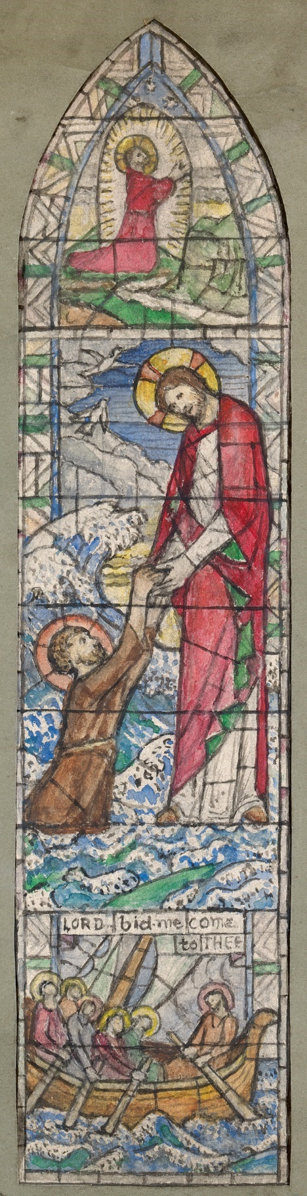
© National Gallery of Ireland
Catherine Amelia O'Brien, artist

You are Invited
to an introduction to Companioned PrayerTM

Monday March 18th
9:30 AM
in the Church Chapel

Members of the [name of church] Companioned Prayer ministry will:
- Discuss the Companioned Prayer ministry
- Lead some brief prayer experiences
- Answer questions

“I hope everyone can participate in the Companioned Prayer program.
It can change your life."
The late Most Reverend Francis Quinn, Bishop
of the Diocese of Sacramento 1979–1993

